Roshdy, Ali

Coursera

Applied Data Science Capstone Project

Report

# **Description of The Problem and A Discussion of The Background**

New Cairo is a recent established county located at the north east of Cairo governorate. New Cairo is recognized with its variety in business categories, and the high-income rates for people live there. Investors have big interest in investing in New Cairo. However, due to its recent development, and the existing of many areas still under development, it is challenging for investors to select the appropriate category of business to invest in, and where it should be located. The reports target to answer those questions.

# **Description of Data Used to Solve the Problem**

Foursquare website provides free service for developers through its website by providing places API from which JSNO file can be extracted that contain useful exploratory information about places.

To assure full coverage of New Cairo count, Google Earth was used to identify the coordinates of the county’s center, and identify the radius parameter for the explore event in Foursquare as demonstrates below:

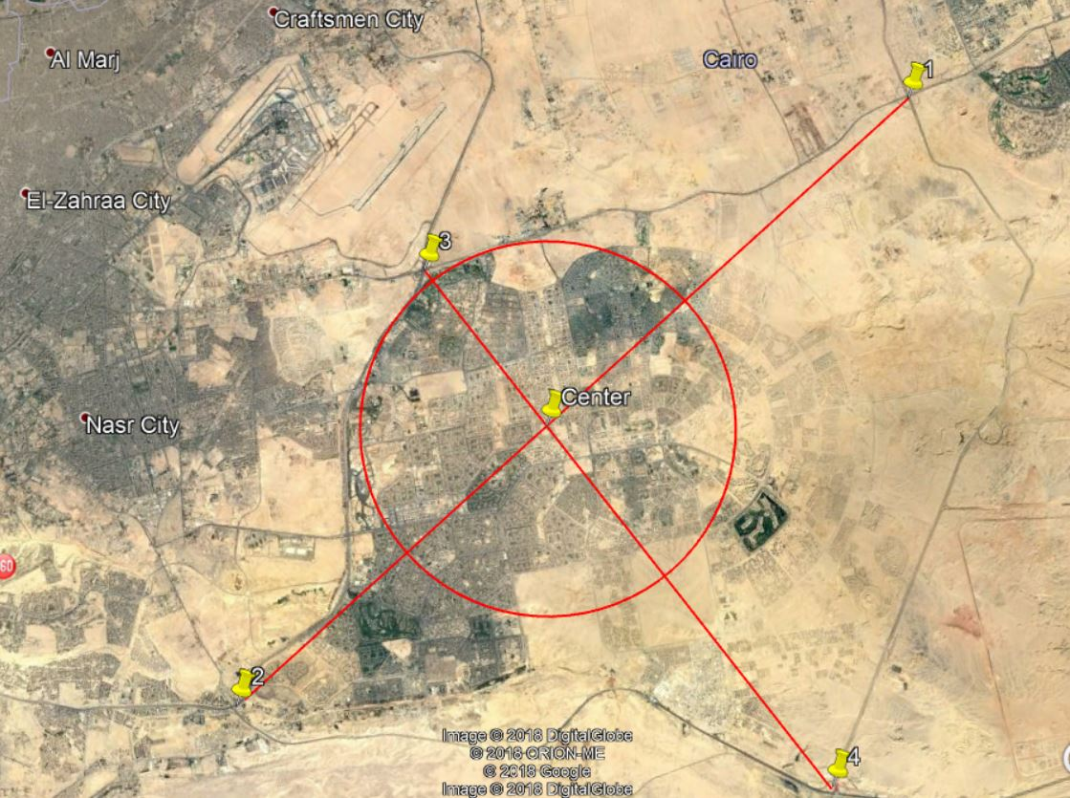

1. **Methodology**
2. JSON file was created from Foursquare API using the explore event
3. Interested information such as (venue name, category, distance to center, latitude, longitude) were extracted from JSON file, and imported in Pandas Data Frame
4. Based on the venue distance to the center it was classified in one of ten classification zones
5. Count analysis and mean calculation was performed on the Data Frame to identify the number of venues in each zone
6. Top five venues were identified for each zone
7. The most common category of venue was identified, and ordered for each zone
8. The Data were clustered using the K mean methodology
9. **Results & Discussion**

* If investors plan to invest in Supermarket Category, then Zone 6 is the best zone for such type of business
* If investors plan to invest in Gift Shop, Gym / Fitness, or Mall then Zone 5 is the best zone for such type of business
* If investors plan to invest in Coffee Shop Category, then Zone 7 is the best zone for such type of business
* If investors plan to invest in Deserts, Entertainment Services, or Market, then Zone 2 is the best zone for such type of business
* If investors plan to invest in Hotel, or American Food, then Zone 4 is the best zone for such type of business
* If investors do not have preference for specific type of business, then Zone 3 is the best zone for such situation as it has different categories

1. **Conclusion**

New Cairo has high protentional for new investment opportunities. After dividing the country into zones, and identifying the type of business in each zone, it figured out that no specific category which dominate the zone which means that there is no saturation from certain category.